8590 Senior Firefighter Begley’s Send off!!!
(Postponed for 2.5 years due to covid)
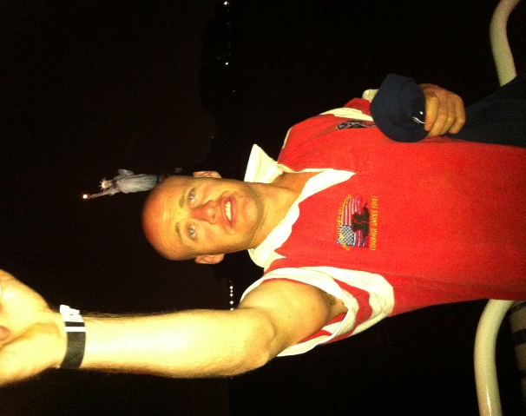
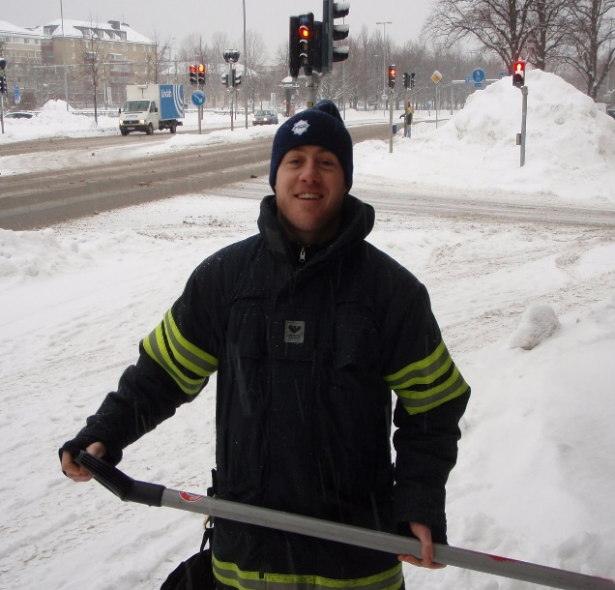

Come and celebrate a career of great tales, & incredible front.

Where: The Edinburgh castle (Pitt St Sydney) upstairs
When: 11th Feb 5PM sharp
Cost: $40
BSB: 802825
Acc: 610028266
Put your name as the reference so I can add you to the door list.
Facebook event: https://fb.me/e/24hiHKHv2
RSVP Matthew.pridham@fire.nsw.gov.au or call Matt Pridham with any questions 0413220971

