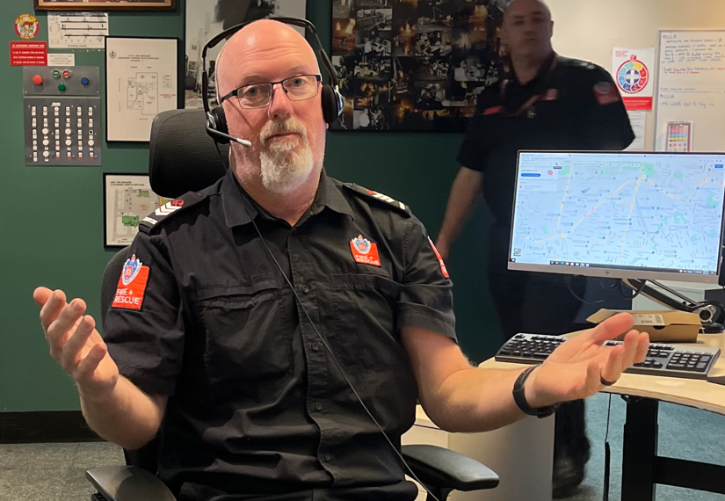  6936 Pat Clancy’s send off  Friday 28th July 2023  1800 – 2300  Where  Royal Hotel Camden  Parlour Room  39 Argyle Street Camden | COST  $ 70 pp  Payments to include full name in reference line.  Account:  Mark Jongkind  Firefighters Mutual Bank  Account # 309561  BSB#802825  Further information – Mark Jongkind  0410 540 982  Mo Haddad  0422 284 330  Payment no later than 14 July 2023– no walk ins will be accepted.  This is a mixed event.

