
NSWFB RETIREES FIRE NEWS
INCIDENT REPORTS


DOONSIDE 3rd ALARM TOWNHOUSE COMPLEX FIRE
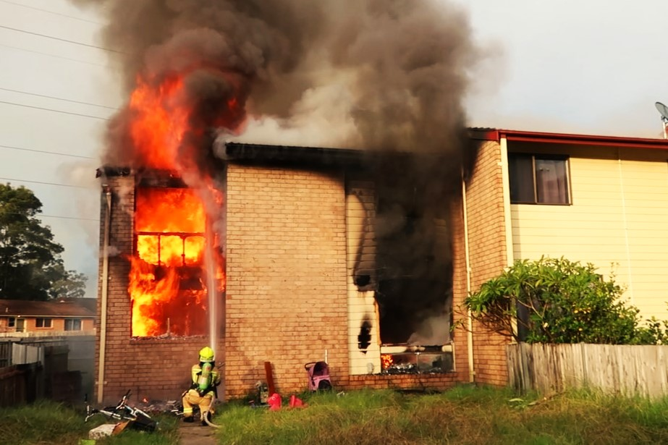
“If I have Seen Further than Others…
It is by Standing on the Shoulders of Giants”


Cover Picture: First arriving firefighters were confronted heavy fire activity from the fully involved townhouse. Fire was beginning to extend to the adjoining exposure and the entire complex was in danger of fire spread.

Incident Video  (Control + Click on YouTube symbols to watch)

Incident Summary:

The day was just starting to get underway for the residents of Belus Way, Doonside when shortly after 0700 hours neighbours saw heavy smoke and intense flames venting from all windows of a townhouse. Neighbours immediately called to ‘000’ to report the fire. FRNSW Fire Communications staff increased the response to a Structure Fire 2nd Alarm due to the high volume of calls being received. As responding firefighters left their stations, a large plume of black smoke was visible in the direction of the call address. First arriving firefighters found a two-level townhouse heavily involved in fire. Firefighters split into two teams; the first crew commenced fire attack. The second crew gained entry into the adjoining exposure, which had large quantities of dark grey smoke venting from the roof and was under immediate threat. Realising an aerial appliance was en route, firefighters ensured room was left at the front of the building for the aerial to be placed in operation. As large flames began to break through the roof of the main fire occupancy, the response was increased to a 3rd Alarm as a precaution to ensure sufficient resources would be available in the event the fire could not be contained to the main fire occupancy. Firefighters conducted a defensive attack on the fully involved townhouse from Alpha and Charlie Sectors. Working with crews operating inside Exposure Delta 1, firefighters established effective containment. Once the aerial appliance commenced operation, fire control was rapidly established. Firefighters successfully located and safely protected neighbour’s pets within the adjoining townhouse.

The main fire occupancy contained a number of furniture items containing significant polyurethane foam content, resulting in extreme fire behaviour, including rapid fire spread, high heat release rates, rapid progression to flashover, intense flames and violent and explosive fire gas ignitions, due to the high quantities of flammable hydrocarbon-based gases released by the polyurethane foam. Some of the key learning points in this paper include the involvement of polyurethane foam-based materials when subject to fire conditions, firefighting operations associated with townhouses and fireground command.

When firefighters arrived on scene at Doonside the two-level main fire occupancy was totally involved in fire, fire was beginning to extend to adjoining Exposure Delta 1 and all other adjoining townhouses in the complex were under threat. Firefighters did an outstanding job correctly placing hose lines that resulted in fire containment, exposure protection and fire control being established. There are many positive lessons to be shared from this fire.

Incident Type: House Fire.

Abbreviations/Acronyms Used in this Report:

BA – Breathing Apparatus.
CAN - Conditions Actions Needs report.
FireComs – FRNSW Fire Communications.
FIRU – Fire Investigation and Research Unit.
FRNSW – Fire and Rescue NSW.
IC – Incident Commander.
ICC – Incident Command Centre.
MFO – Main Fire Occupancy.
RPAS – Remotely Piloted Aerial System.
SAR – Search and Rescue.
SCBA – Self Contained Breathing Apparatus.
SFF – Senior Firefighter.
SO – Station Officer.

Time, Date and Place of Call:

0704 hours on Wednesday 24th April 2024, 12 Belus Way, Doonside.

FRNSW Response:

Aerial Pumper 97 (Huntingwood), Rescue Pumpers 63 (Blacktown) and 57 (Wentworthville), Pumpers 43 (Seven Hills), 96 (Schofields) and 27 (Parramatta), CAFS Pumpers 32 (Mount Druitt) and 67 (Baulkham Hills), Hazmat Pumper 77 (St Marys), Technical Rescue 63, Heavy Hazmat 77, Ladder Platform 27 (Parramatta), Mobile Command Centre Bravo, Logistics Support Vehicle 97, Duty Commanders MW1 (West) and MW2 (Parramatta), Zone Commander MW1, Team Leader Aviation, Aviation Officer Alpha, Fire Investigation and Research Unit, Team Leader K9 and Operational Media Officer Superintendent Guy Lightfoot.

Additional Agencies/Services in Attendance:

NSW Police Force, NSW Ambulance, Electricity Authority and Department of Housing.

Fireground Description:

The fireground consisted of a row of six two-level townhouses, 60 m x 10 m, joined together and located offset to each other. Individual townhouses were 10 m x 10 m, timber frame, brick clad and tile roof construction.

The main fire occupancy (12 Belus Way) was located at the eastern end of the row. This townhouse contained three bedrooms on the second level. At the time of the fire there were five polyurethane foam mattresses on the second level. Exposure Delta 1 (13 Belus Way) was separated from the main fire occupancy by a double brick wall that extended to the tile roof. There were gaps and openings between the top of the wall and the roof tiles.

Belus Way was 6.0 m wide concrete surface crescent shaped access driveway. Cars were parked on the sides of Belus Way and trees located near the sides of Belus Way, restricting access. Belus Way terminated at a dead end with one entry point only from Helios Crescent.

A hydrant was located at the eastern end of Belus Way and was covered in grass. The next closest hydrant was located on Helios Crescent 5.0 metres to the west of Belus Way.

Fireground Installed Firefighting Systems:

The main fire occupancy contained installed working residential smoke alarms.

Weather at Time of Call:

Temperature 15.1°C (apparent 14.3°C), relative humidity 76%, Winds north at 6 km/h, gusting to 11 km/h, nil rain, cloud 2/8 and mean sea level pressure 1016.3 hPa recorded at Bureau of Meteorology Horsley Park automatic weather station (approximately 6.5 km from the fireground).

Situation Prior to FRNSW Arriving on Scene:

Ordinarily, two adults and four children resided at the main fire occupancy. It is believed these persons were not at home when the fire broke out and the house was unoccupied. Shortly after 0700 hours on Wednesday 24th April 2024, neighbours first observed smoke and flames venting from the windows of the main fire occupancy. When neighbours first observed the fire, intense flames and heavy smoke were venting from all windows on levels one and two.

Fire Behaviour Considerations

The following fire behaviour considerations are of note:

1. The Main Fire Occupancy (MFO) contained several lounges and chairs formed with polyurethane foam cushioning on level one and five polyurethane foam mattresses within three bedrooms on level two.

2. Within a short time of fire breaking out, fire quickly spread to the lounges and chairs on level one. Involvement of the polyurethane foam cushioning resulted in a rapid escalation of fire conditions.

3. Fire intensity associated with the burning polyurethane foam cushioning was extreme. National Institute of Standards and Technology (NIST) fire testing has identified Heat Release Rates of 1070 kW to 1110 kW produced by burning polyurethane foam. Flame temperatures reaching up to 820 degrees Celsius are measured for polyurethane foam. A peak heat flux density (heat rate per unit area) of 760 kW/m² is calculated for this material.

4. The burning polyurethane foam resulted in the release of a hydrocarbon super-enriched atmosphere on level one of the townhouse. Intense heat from the rapidly developing fire resulted in all ground level glass windows failing, allowing increased volumes of oxygen to mix with large volumes of superheated unburnt hydrocarbon material within the venting fire gases (which were now within their flammable range), resulting in violent and explosive gas ignitions.

5. The intensity of the fire was indicated by the level of damage to the aluminium window frames and security doors. The upper levels of the front and rear door aluminium frame security screen doors and aluminium window frames had melted down to a height of 60 cm above floor level, indicating temperatures that exceeded 660°C at this level. Temperatures at ceiling level were much greater, resulting in the gyprock ceiling being completely destroyed, exposing the timber second level floor frame and flooring, which were now being attacked by the fire.

6. Fire rapidly spread from level one to level two via:

a. The open timber stairwell (which subsequently collapsed due to heavy fire impact)
b. Auto exposure from flames venting externally from level one, causing breaching of windows on level two and fire entry.
c. Fire penetration through the level two timber floor.

7. Level two contained five polyurethane foam mattresses within three bedrooms. The polyurethane foam within these mattresses rapidly became involved in fire, producing extreme fire conditions including heavily venting fire and violent and explosive gas ignitions.

8. Failure of the second level ceiling allowed highly flammable superheated hydrocarbon-laden gases to enter the roof space. Burning fire gases within the roof space were venting with high pressure and high velocity, breaching the openings between the brick separation wall and entering the roof space of adjoining Exposure Delta 1, placing this exposure at risk of imminent fire spread due to ignition of roof space materials (roof timbers, void dust, PVC, insulation and other accumulated materials).

9. The entire first and second levels and roof space of the main fire occupancy were now fully involved in fire. Fire intensity caused severe attack of the roof frame, resulting failure of the roof rafters, bearers and battens, resulting in total roof collapse occurring. Flames began to vent at least 10 metres above the roof line of the main fire occupancy. In addition to fire gases entering the Exposure Delta 1 roof space, intense radiant heat from venting flames was also impacting Exposure Delta 1.

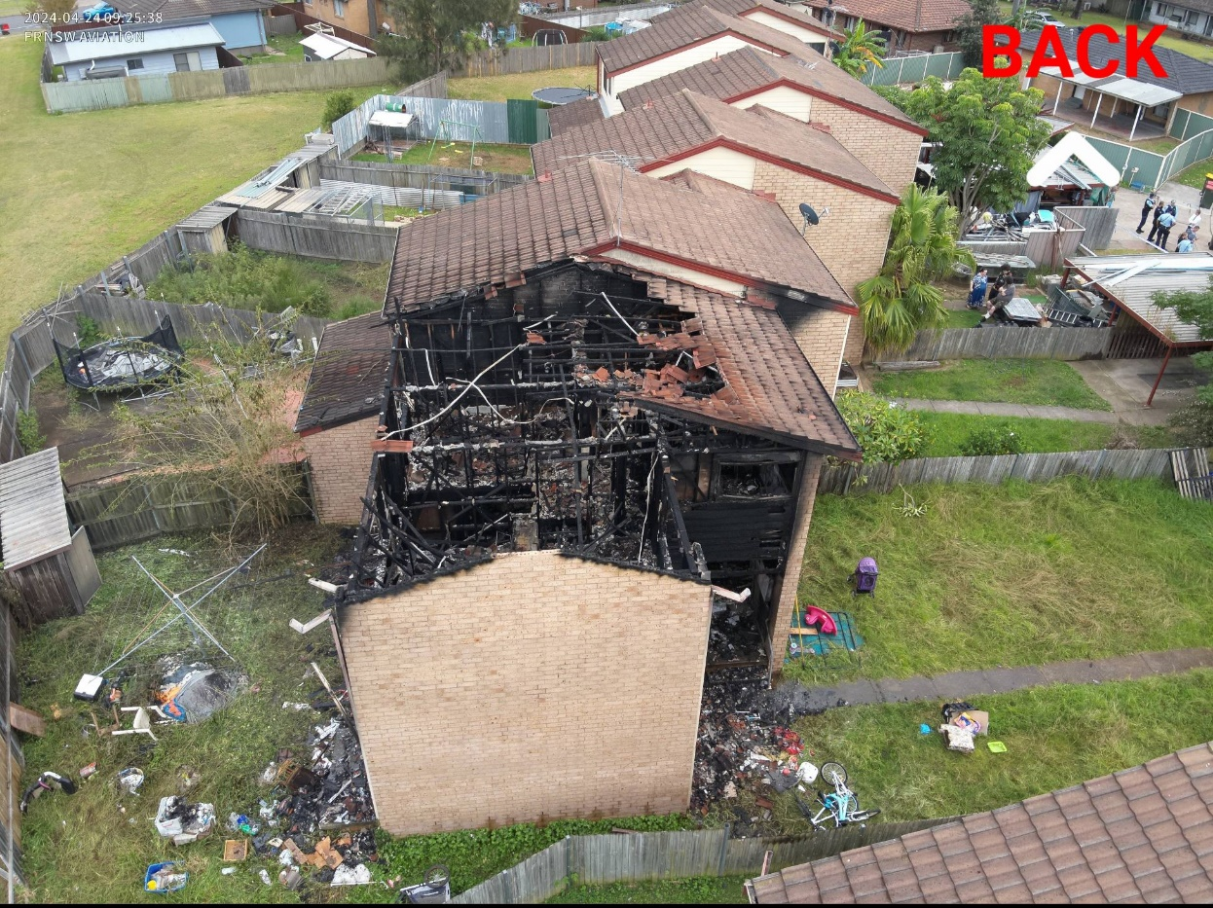
F
E
D
C
B
A
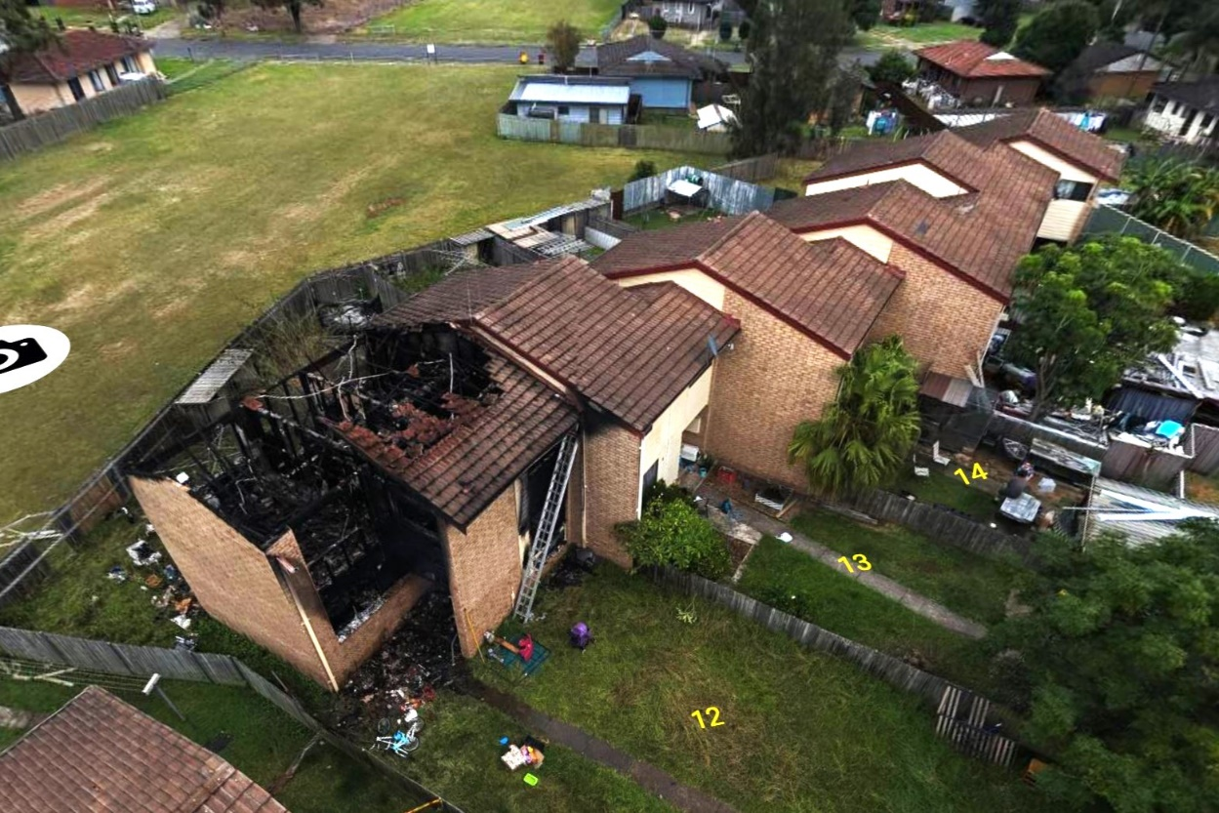
F
D
C
B
A

Aerial view of Fireground, courtesy FRNSW Aviation Section

A Main Fire Occupancy.
B Exposure Delta 1.
C Wall separating Main Fire Occupancy from Exposure Delta 1 – Fire breach at top of wall.
D Secondary breach into Exposure Delta 1 roof space.
E Electricity Distribution Board.
F Unstable Bravo Side Wall.
Initial Call and Response:

At 0704 hours on Wednesday 24th April 2024, FRNSW Fire Communications received the first of numerous ‘000’ calls reporting a house fire at 12 Belus Way, Doonside. Rescue Pumper 63 and Aerial Pumper 97 were initially assigned to the call. As Fire Communications began to receive additional ‘000’ calls reporting smoke and heavy flames issuing from the call address, the Fire Communications supervisor increased the response to a Structure Fire 2nd Alarm 0t 0706 hours, resulting in the additional assignment of Pumper 43, CAFS Pumper 32, Technical Rescue 63, Hazmat Pumper 77, Ladder Platform 27 and Duty Commander MW1 (West).

Almost as soon as the initial appliances left their stations, firefighters could see a large column of thick black smoke in the direction of the call address. At 0709 hours Duty Commander MW1 sent the following RED message whilst en route:

“FIRECOMS DUTY COMMANDER WEST RED! RESPONDING EN ROUTE HAVE LARGE VOLUMES OF BLACK SMOKE VISIBLE. CONFIRM STRUCTURE FIRE 2ND ALARM, OVER.”

The size, colour and density of the smoke column were all indicative of advanced fire conditions. Responding Duty Commander West formed the view that due to the intensity of the fire, the most effective way of establishing fire control would be with the use of an aerial appliance. Duty Commander West sent a message to Fire Communications requesting all responding appliances leave room for the aerial appliance. This message was passed to all responding 2nd Alarm trucks.

First Crews Arrive on Scene:

Rescue Pumper 63, under the command of S.O. Craig Hensby, was the first appliance to arrive on scene. Upon arrival firefighters observed fierce flames venting from every window on the first and second levels of the townhouse. A large column of black smoke was venting from the roof of the structure. Heavy dark grey/dark brown smoke was venting from the eaves of adjoining Exposure Delta 1 to the west of the fully involved townhouse.

Rescue Pumper 63 travelled a short distance past the involved townhouse, allowing fire attack lines to be laid directly towards the fire. This also left room for the aerial appliance to position and go into operation. S.O. Hensby established command and at 0712 hours sent the following RED message:

“FIRECOMS RESCUE PUMPER 63 RED! FROM 12 BELUS WAY DOONSIDE, WE HAVE A TOWNHOUSE, BRICK AND TILE CONSTRUCTION, TOTALLY INVOLVED IN FIRE. COMMENCING FIRE ATTACK. CONFIRM STRUCTURE FIRE 2ND ALARM, OVER.”

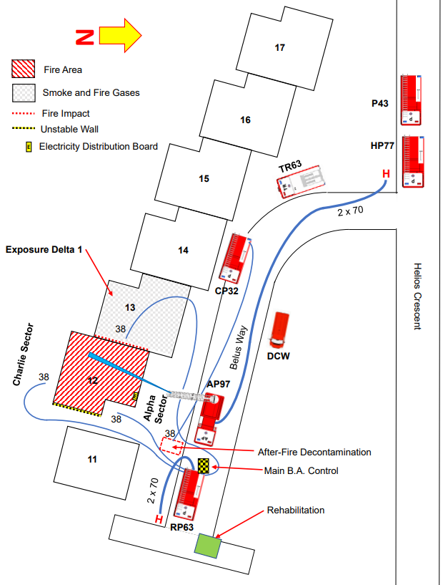

Fireground Drawing
Not to scale
Initial Firefighting Operations:

Rescue Pumper 63 firefighters began to deploy the first 38 mm attack line to the front of the fully involved townhouse and commenced to direct the attack stream onto the fire. The crew of Technical Rescue 63 had arrived on scene a short time after Rescue Pumper 63 and Firefighters Shane Park and Robert Wright wearing SCBA began to deploy a second 38 mm line through the front of Exposure Delta 1 to the second level via the internal stairs. Firefighters used a ceiling hook to create openings in the ceiling and began to direct sprays onto fire coming through the gaps between the top of the wall and roof tiles into the Exposure Delta 1 roof space. Aerial Pumper 97 Firefighters Leon Duke and Tristian Woods wearing SCBA conducted a primary search of Exposure Delta, finding no persons present.

The fire was beginning to extend into Exposure Delta 1 through gaps between the top of the separation wall and the roof tiles. The above actions of firefighters stopped this fire spread from occurring, protecting Exposure Delta 1 and the remainder of the complex.

Response Increased to Structure Fire 3rd Alarm:

Duty Commander MW1 Inspector Kernin Lambert arrived on scene and observed the townhouse was fully involved in fire, conditions were intensifying and heavy smoke was venting under pressure from the roof exposure Delta 1, indicating the fire was continuing to spread, placing Exposure Delta 1 in imminent danger. At 0714 hours Duty Commander West increased the response to a Structure Fire 3rd Alarm to ensure there were sufficient resources to stop the fire spreading and establish fire control.

Transfer of Command:

Duty Commander West arrived on scene and following a handover briefing with S.O. Hensby, command was transferred to Duty Commander West and S.O. Hensby appointed Operations Officer. The Incident Command Point was established at the Duty Commander vehicle.

Pumper 43, under the command of S.O. Brad McWilliams, arrived on scene and firefighters were tasked to commence attacking the fire from the Charlie side. Pumper 43 firefighters laid a 38 mm line from Rescue Pumper 63 to the Charlie Side of the main fire occupancy and commenced to attack fire venting through breached windows of levels one and two of the involved townhouse. At 0720 hours the I.C. sent the following strategic CAN report:

“FIRECOMS DUTY COMMANDER WEST, DOONSIDE COMMAND BLUE. WE HAVE A FIRE INVOLVING A ROW OF SIX TWO-LEVEL TOWNHOUSES. NUMBER 12 IS TOTALLY INVOLVED IN FIRE. SMOKE IS VENTING FROM THE ROOF OF EXPOSURE DELTA 1, NUMBER 13. WE ARE OPERATING IN THE DEFENSIVE STRATEGY ON NUMBER 12 WITH TWO 38 MM LINES AND ARE IN THE OFFENSIVE STRATEGY WITHIN NUMBER 13 OPERATING ONE 38 MM LINE. WE ARE PREPARING TO PLACE AERIAL PUMPER 97 IN OPERATION. WE WILL MAINTAIN THE 3RD ALARM UNTIL WE HAVE CONTAINED THE FIRE. STAGING AREA IS LOCATED ON HELIOS CRESCENT TO THE WEST OF THE ENTRANCE TO BELUS WAY, OVER.”

Preparations for Aerial Attack:

Realising the fire was continuing to increase in intensity, the I.C. directed Aerial Pumper 97 to come onto the fireground, position at the front of the fire building and go into operation. The I.C. passed a message for the next arriving appliance to locate a hydrant on Helios Crescent and lay supply lines to Aerial Pumper 97. Hazmat Pumper 77 under the command of S.O. Andrew Tonkih were arriving on scene when firefighters overheard the message from the I.C. and began to locate a hydrant and lay twin 70 mm lines from the hydrant to Aerial Pumper 97. S.O. Tonkih was appointed Delta Commander and the crew of Hazmat Pumper 77 were tasked as the fireground On-Deck crew.

Electricity Unable to be Switched Off:

The electricity distribution board for the main fire occupancy was located within the entranceway to the Townhouse, was being heavily impacted by fire and inaccessible to firefighters. Shortly after firefighters arrived on scene, loud arcing could be heard coming from the vicinity of the electricity distribution board. The I.C. sent a message requesting the urgent attendance of the electricity authority, reporting the electricity distribution board was being impacted by fire and could not be switched off. All firefighters were warned via a general fireground broadcast of this hazard. Electricity to Exposure Delta 1 was switched off at the electricity distribution board.

Aerial Appliance Placed in Operation:

Firefighters were now attacking the from Alpha, Charlie and Delta sides. The Bravo side of the main fire occupancy consisted of a windowless brick wall preventing access of firefighting streams and no operations were being undertaken from this side of the main fire occupancy. Fire began to break through the roof and large flames began to vent at least 10 metres above the roof line. Exposure Delta 1 remained in danger due to the high levels of heat being produced by the venting flames. Water supply had been secured to Aerial Pumper 97 and the aerial boom was elevated and extended ready to commence operation. The aerial operator was instructed to direct the aerial stream through the breached roof and to cool the wall adjoining Exposure Delta 1. All firefighters were informed the aerial was about to be placed in operation. No firefighters were operating in zones that could have been impacted by the aerial steam. Aerial operations commenced, producing an almost immediate effect, significantly reducing fire intensity. This operation allowed fire control to be rapidly established and ensured protection of the threatened Exposure Delta 1, enabling the I.C. to reduce the response from a 3rd to a 2nd Alarm at 0722 hours.

Firefighter Decontamination and Rehabilitation:

CAFS Pumper 32 under the command of S.O. Cliff Van Eck were tasked with stablishing firefighter decontamination. A decontamination zone was established at the entrance to the main fire occupancy. A firefighter rehabilitation area was established beyond the decontamination zone.

Pets Safely Located:

The occupants of Exposure Delta 1 reported a number of pets were located within their townhouse. Firefighters conducted a search of Exposure Delta 1 and located a number of cats and kittens, in rooms where the air was clear. A decision was made to keep the pets within the townhouse, to avoid unnecessarily distressing them and because they were no longer at risk.

Collapse Zone Established:

Charlie Sector Commander observed outward movement of the Bravo side two level brick wall. This information was relayed to the I.C. and a collapse zone established on the Bravo side of the main fire occupancy. All firefighters were informed of the collapse zone via general fireground broadcast. Fire communications were similarly informed of the establishment of the collapse zone.

Fire Control Established:

Within a short time of aerial operations commencing there was a significant reduction in fire intensity. The aerial appliance was shutdown, allowing firefighters operating 38 mm hose lines to complete final extinguishment.

Electricity Isolated:

Electricity operators attended the scene and were requested to isolate power to the main fire occupancy. Firefighters informed electricity staff the power was unable to be switched off and the electricity distribution board had been destroyed by the fire. Electricity operators isolated power and informed the I.C. isolation to the main fire occupancy was confirmed. This information was passed via general fireground broadcast to all firefighters and also to Fire Communications.

Search Operations:

Firefighters had been unable to conduct any type of search of the main fire occupancy due to the advanced fire conditions present. As fire control was being established, Police informed the I.C. they believed two adults and four children usually resided at the main fire occupancy, however their whereabouts was currently unknown. As soon as conditions permitted, firefighters were detailed to conduct an exterior search of the ground level from Alpha and Charlie sides. At this time, the roof had collapsed, the Bravo side wall was unstable and the second level timber floor structure had been severely impacted by fire and was structurally compromised, preventing an interior search.

The exterior level one search did not indicate any persons present. Firefighters used a ladder to access level two and an exterior search of the second level was similarly conducted, which also found no signs of persons present. The I.C. requested the attendance of the RPAS (Remotely Piloted Aerial System) to assist the search. Team Leader Aviation Inspector Russell Turner and Aviation Officer Delta Senior Firefighter Shawn Addison attended the scene.
The aviation officers conducted a fly through of the main fire occupancy, which similarly could not detect any signs of persons within the building. As the RPAS search was concluding, Police advised the family of six persons had been located safe at a relative’s house.

Post Fire Operations:

At the completion of salvage and overhaul operations firefighters conducted further inspections of the roof space above Exposure Delta 1 and found no areas of elevated temperature present. Atmospheric monitoring of Exposure Delta 1 similarly confirmed the atmosphere within the townhouse was clear. All FRNSW appliances were then released from the scene.

The site was then handed over to Police who established a crime scene. FRNSW Fire Investigation and Research Unit investigator Inspector Chris Hughes and FRNSW K9 unit attended the scene to assist police crime scene examiners undertake cause and origin determinations. Several days after the fire, local stations reattended the scene and conducted reactive home fire safety visits of all houses within Bellus Way.

Conclusion:

First arriving firefighters at Belus Way, Doonside, found a two-level townhouse totally involved in fire. A significant fuel load consisting of polyurethane foam-based furniture produced extreme fire conditions, placing the adjoining exposure under heavy threat. Firefighters immediately commenced operations to attack the fire and protect the exposure. As additional resources arrived on scene, additional lines were placed in operation securing the fire flanks and increasing the strength of fire attack. An aerial appliance was placed in operation, enabling fire control to be established. In a systematic and coordinated operation, firefighters rapidly established containment, protection of exposures and fire control. There are many positive lessons to be shared from the textbook firefighting operations at Belus Way, Doonside.

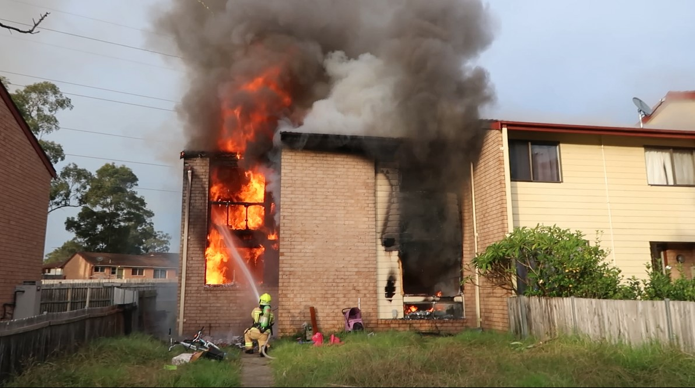

Initial fire attack has knocked down fire adjacent to Exposure Delta 1. The attack stream is now being directed to fire on the Bravo side of the involved townhouse.
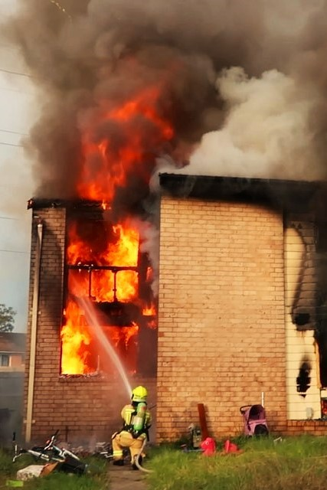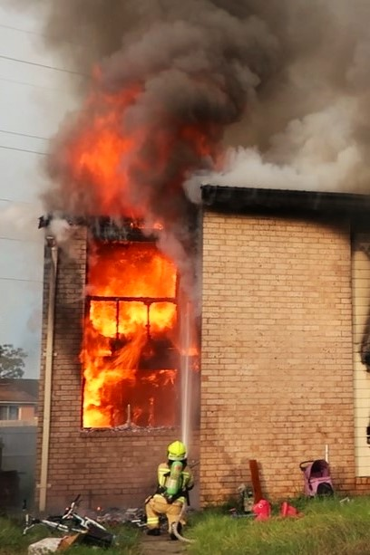
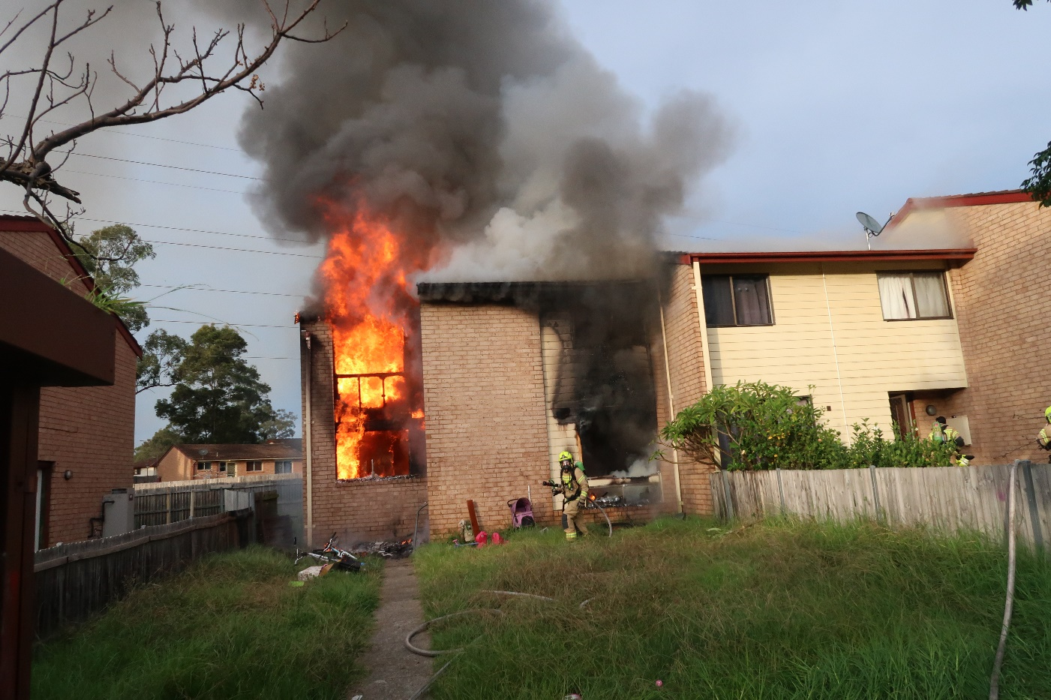

Initial fire attack has resulted in fire being knocked down on levels 1 and 2 of the involved townhouse close to the Exposure Delta 1 wall and the line is now being repositioned to the Bravo side of the townhouse. In the lower photograph, the initial exposure protection team can be seen advancing a line into Exposure Delta 1. Note the fire intensity above the roof line (particularly bottom photograph), indicative of the hydrocarbon-based fuel load associated with the polyurethane foam mattresses burning in the second level bedrooms.
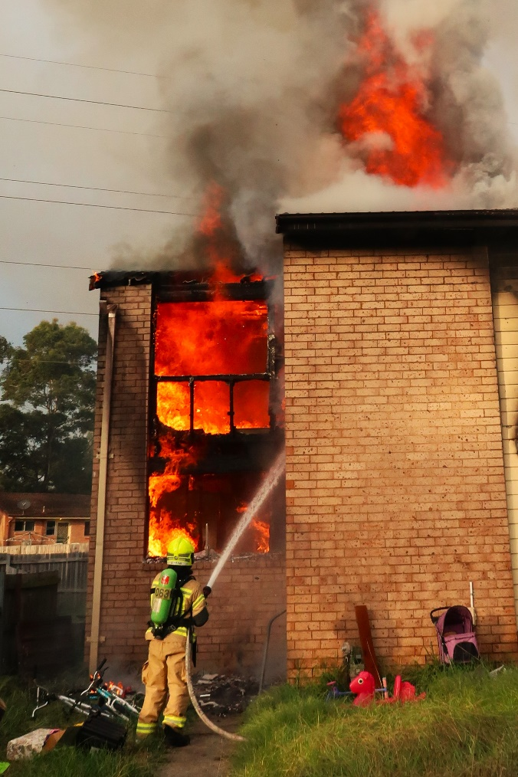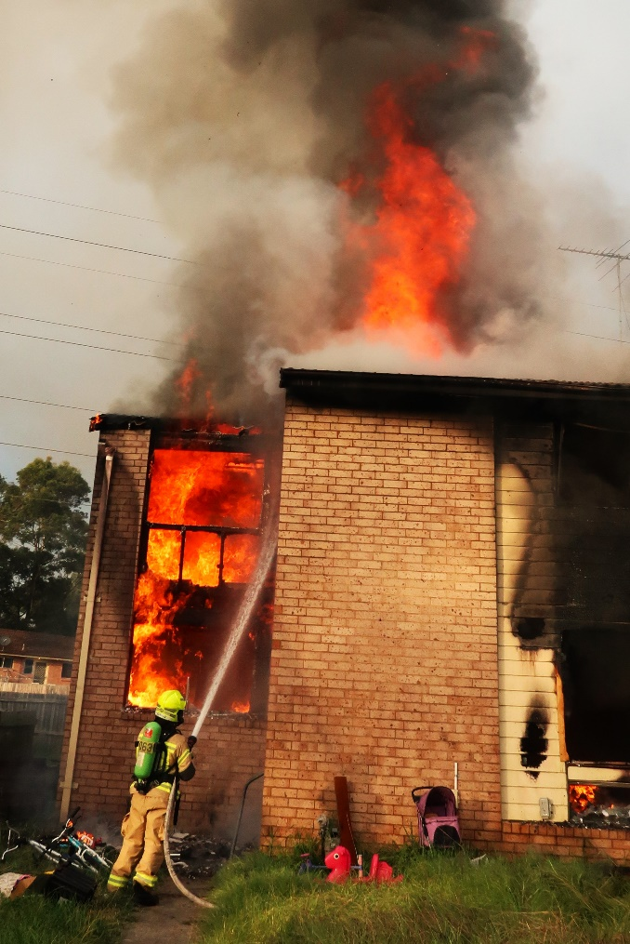

Fire begins to vent through the roof of the townhouse. The exposure protection team have entered Exposure Delta 1, opened the ceiling and are operating a 38 mm line ensuring fire does not pass the separation wall and enter the roof space above Exposure Delta 1. Despite encountering fierce fire conditions, firefighters halted the spread of fire, saving a further five adjoining townhouses. This is a great example of excellent tactical placement of hose lines by firefighters, under the direction of first arriving Rescue Pumper 63 S.O. Craig Hensby.
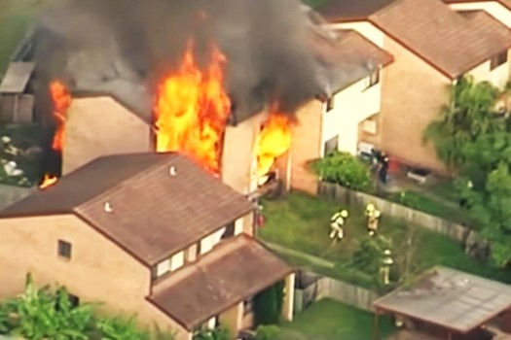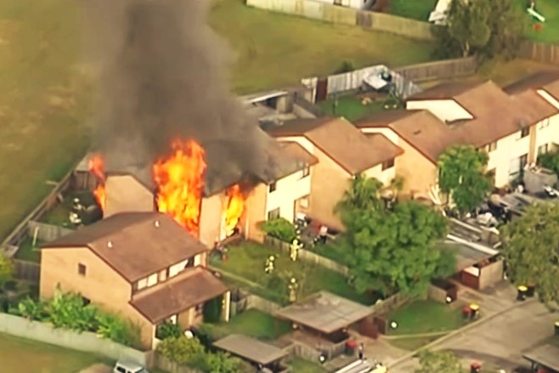
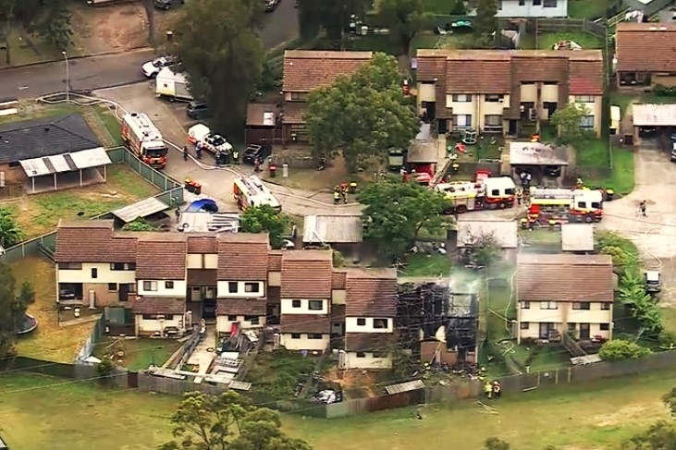
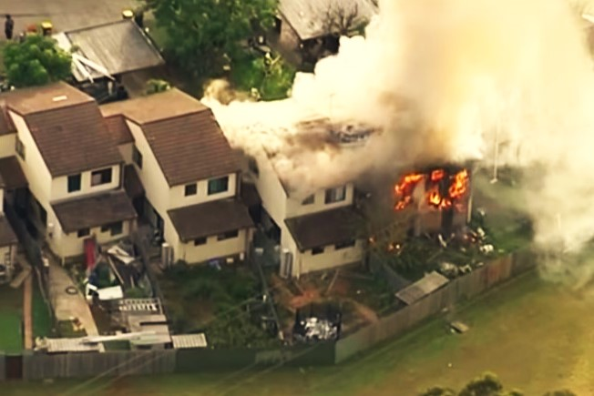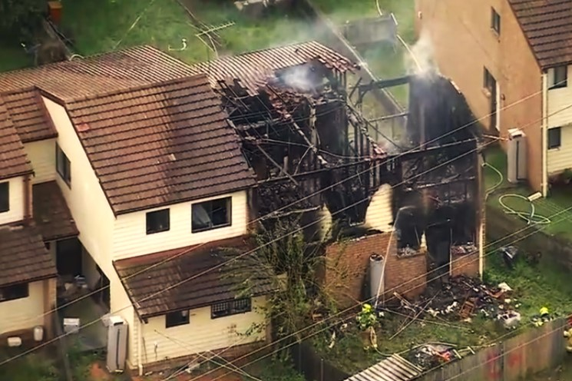

Upper: News traffic helicopter pictures of the main fire occupancy as firefighters began to lay the first attack lines. Heavy flames vent from every opening. Middle: Aerial view of the fireground. Lower: News traffic helicopter pictures from the Charlie Side of the fireground. Lower left shows smoke pouring from the roof space of Exposure Delta 1 (indicated by arrow). This exposure was in imminent danger, however excellent work by firefighters prevented fire from spreading to this exposure. Wet tiles on the roof of Exposure Delta 1 are indicative of the placement of protective water streams.

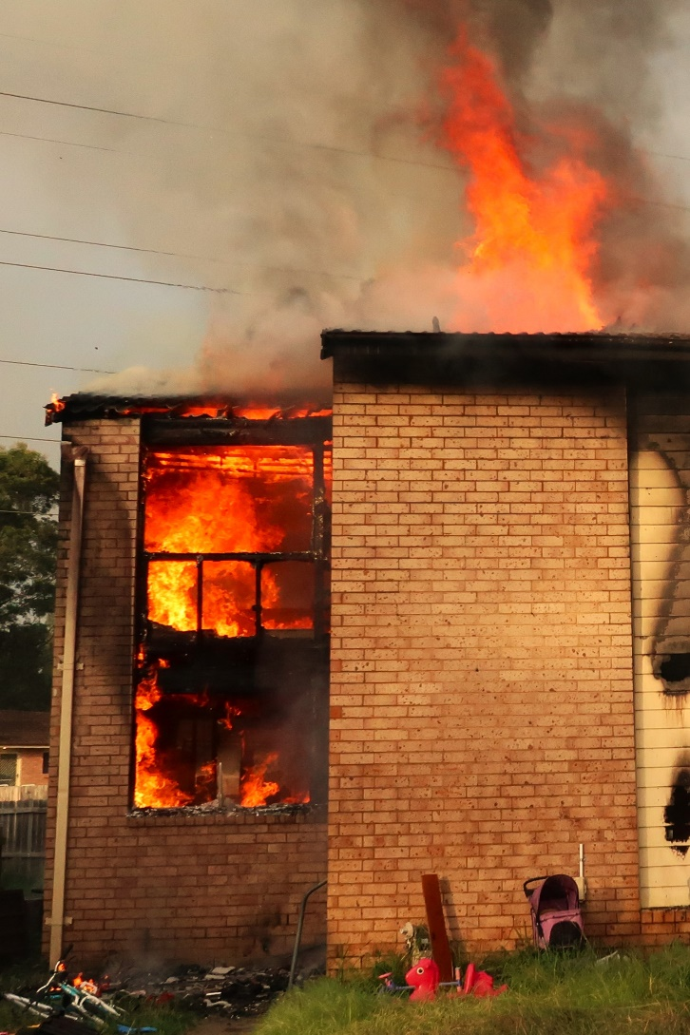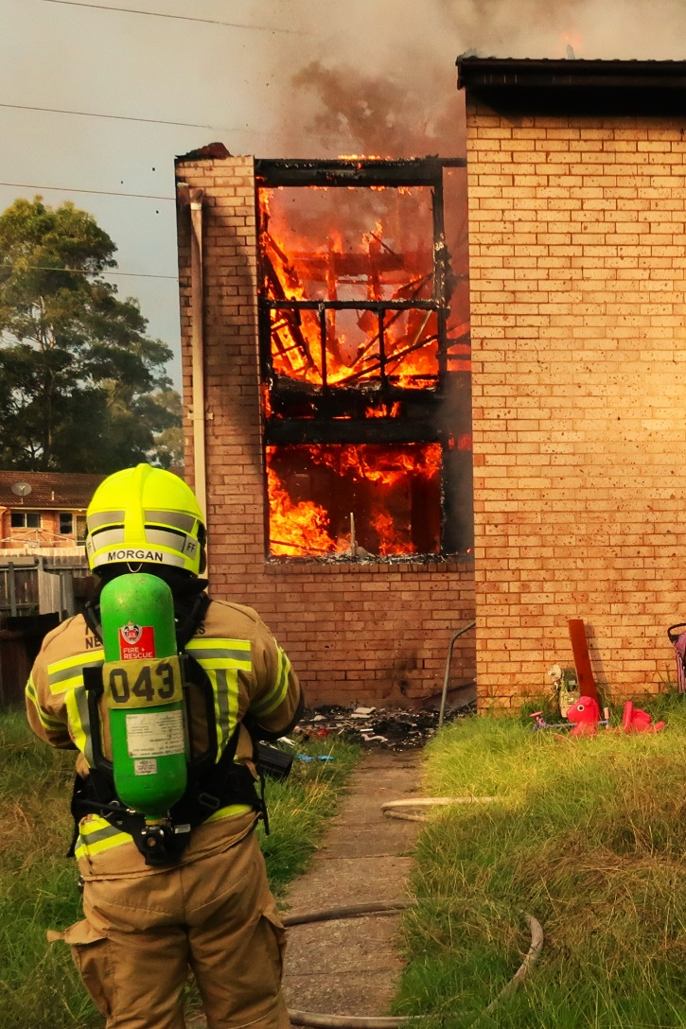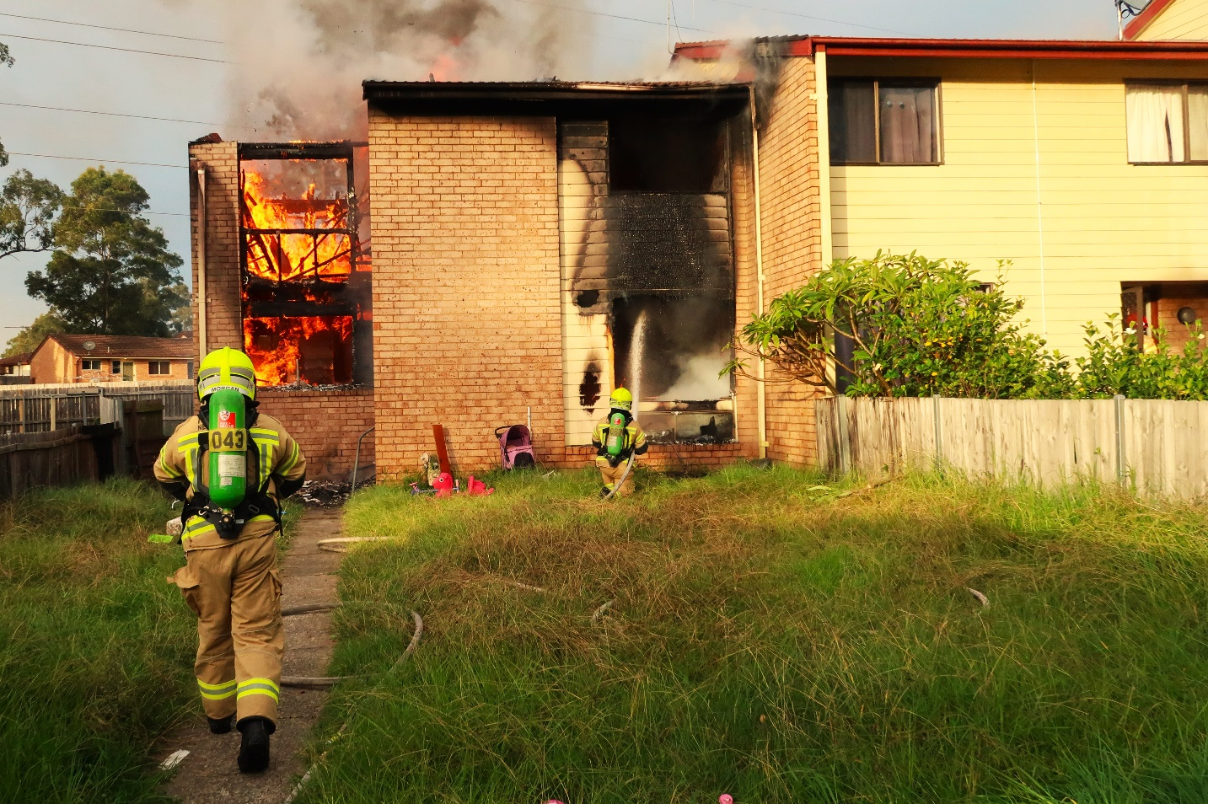
B
B
A

Total roof structure collapse: Due to the advanced fire conditions firefighters are operating defensively. Heavy fire impact to the roof frame timbers A resulted in total roof collapse occurring B. Defensive operations ensured all firefighters remained safe when the collapse occurred.
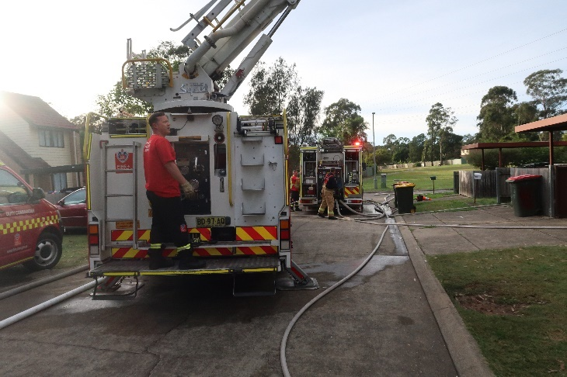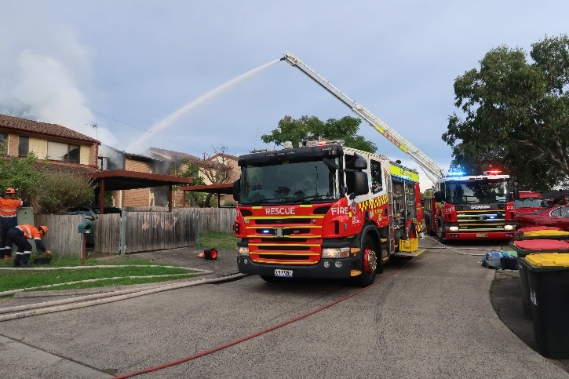
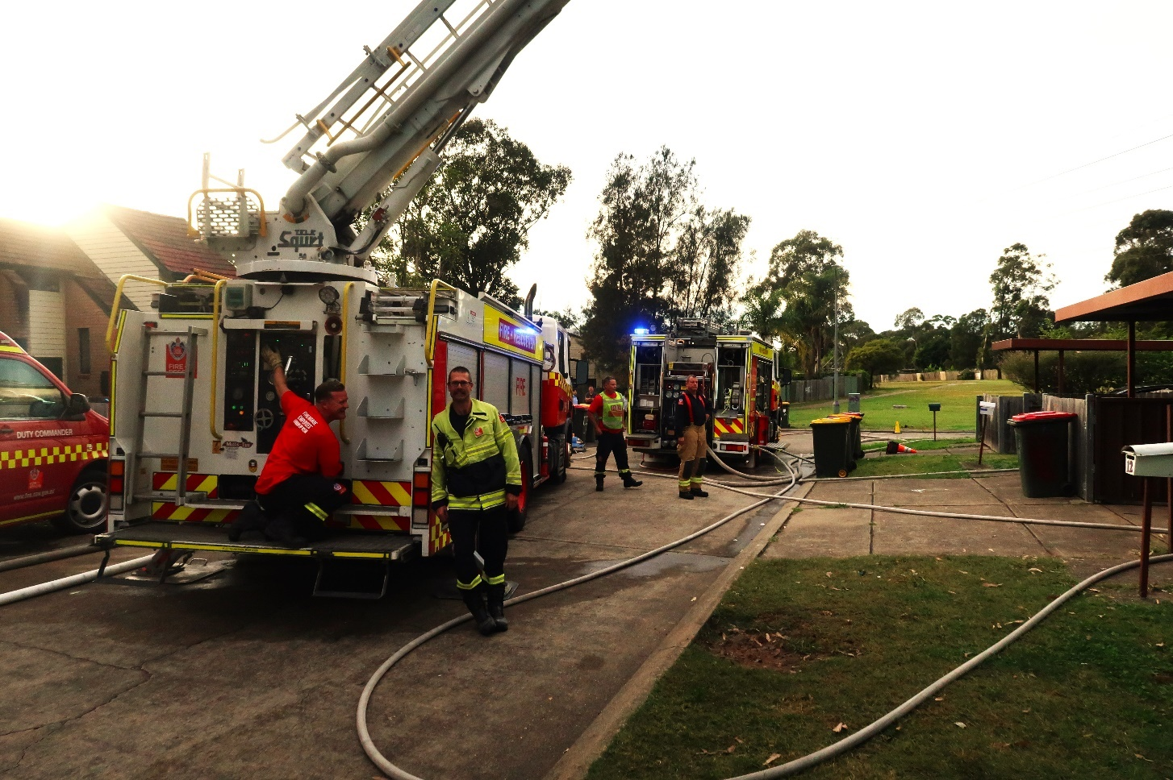
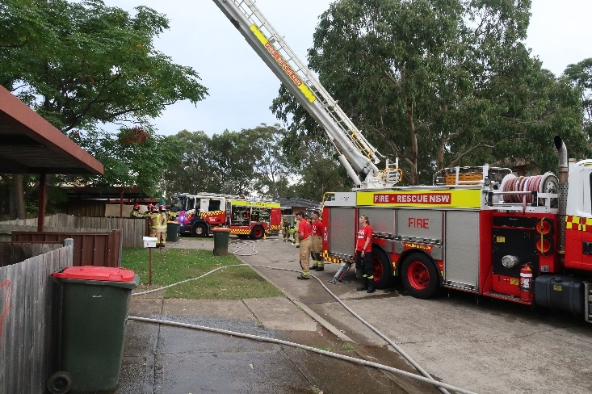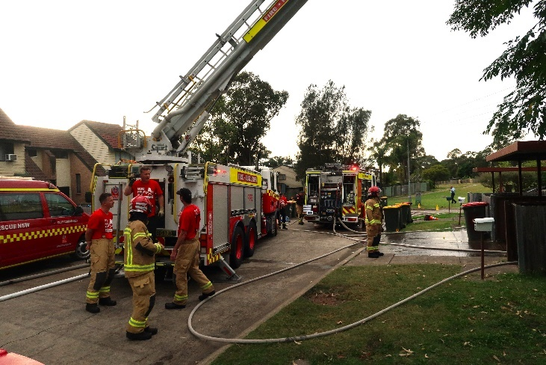

Outstanding work by the Aerial Pumper 97 aerial crew contributed to the progression of the fire being stopped. AP97 operator SFF Gavin Hartge directed a precision aerial master stream onto the fire, greatly reducing fire intensity and cooling the wall separating the involved townhouse from adjoining Exposure Delta 1. The actions of initial arriving crews leaving room for the aerial appliance was very beneficial.

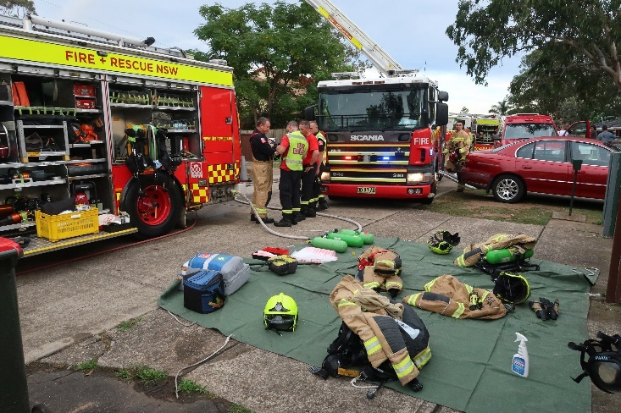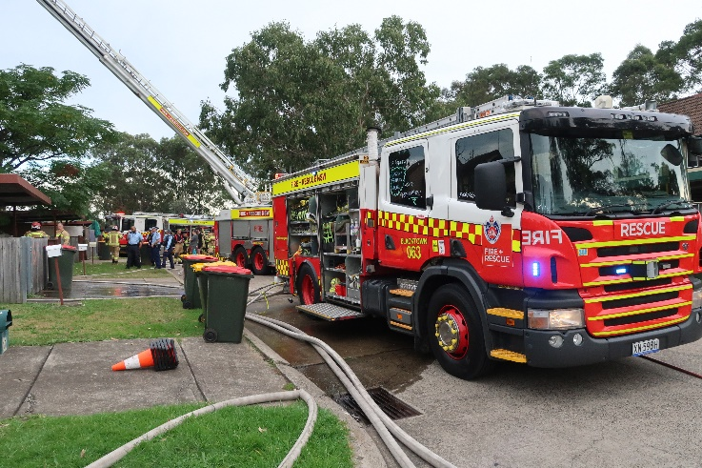
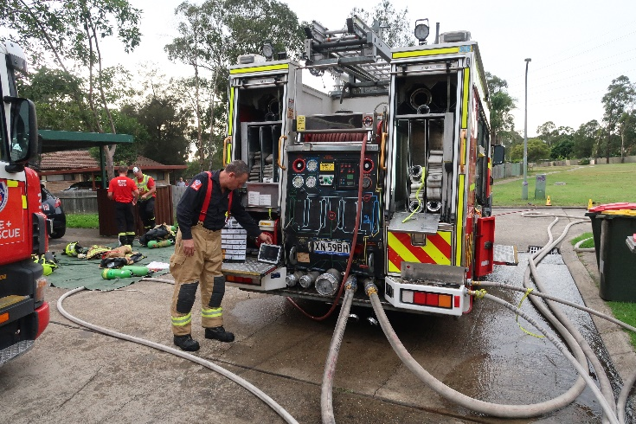
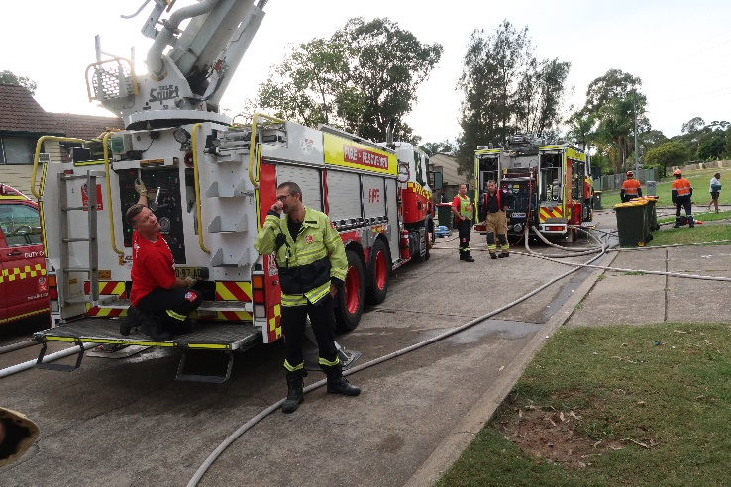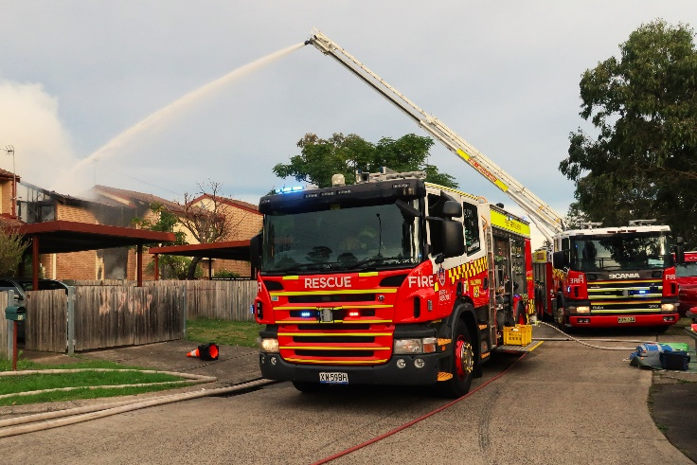

The outstanding work of Rescue Pumper 63 pump operator SFF Al Atkin cannot be overlooked; placemnet of the appliance, securing water supply, pump operation, radio communications, excellent local knowledge and establishment of Main B.A. Control, initial firefighter decontamination and firefighter rehabilitation were among the many tasks performed by SFF Atkin (to a high standard) that enabled the fireground to operate with safety and efficiency.
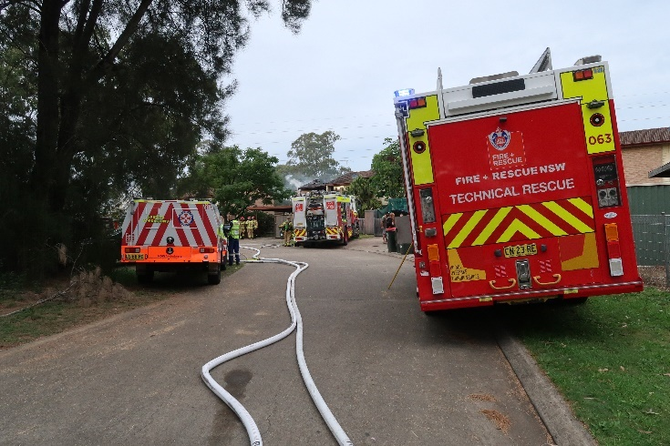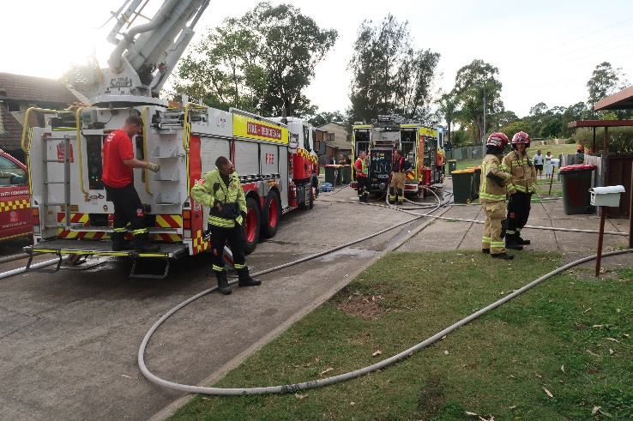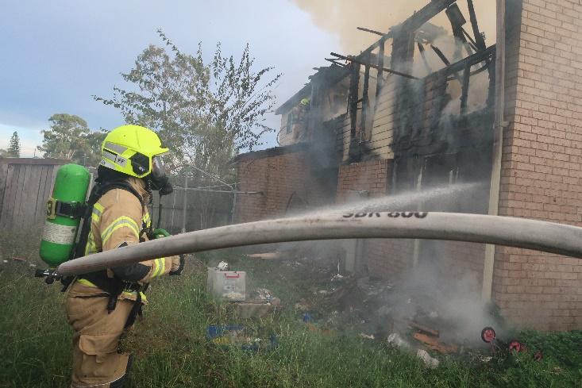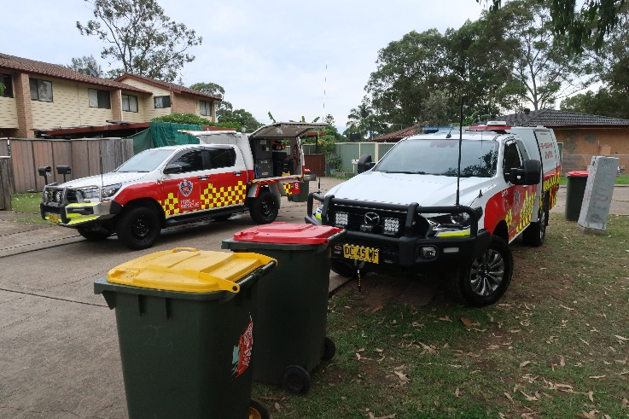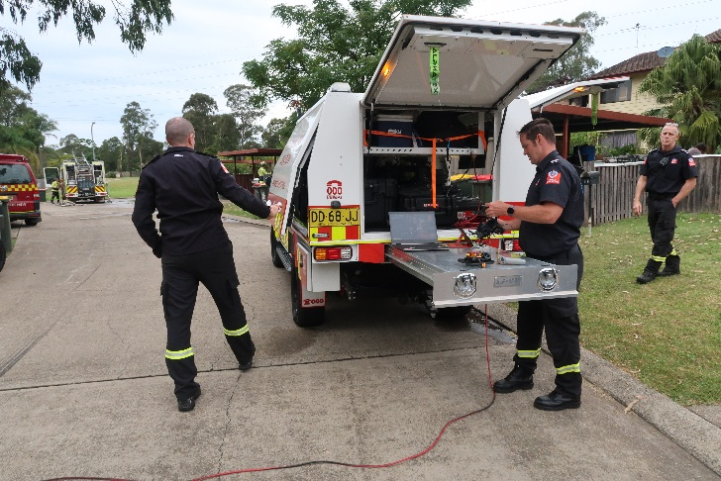

Top: Operations on the Alpha side of the fireground. Middle: Pumper 43 firefighters attack the fire from Charlie Sector. Lower: FRNSW Aviation section provided invaluable support to operations, using the RPAS (Remotely Piloted Aerial Vehicle) to assist the search of the main fire occupancy, where occupants at that time had not been accounted for. The structure was unstable to severe fire impact.

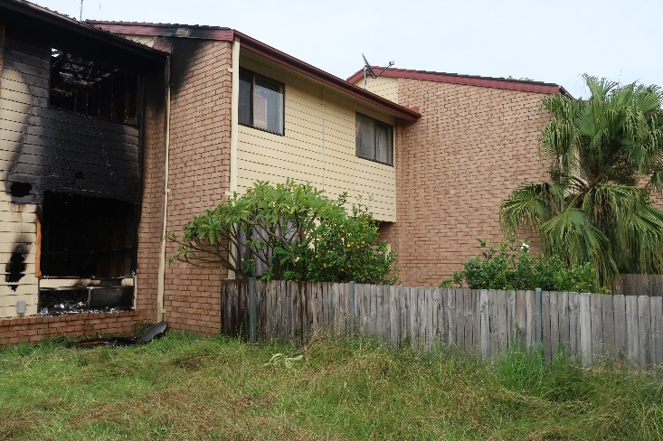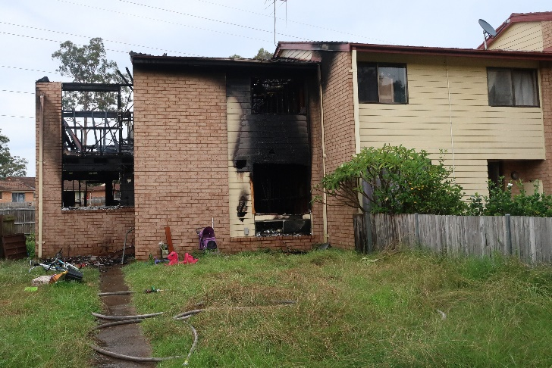
E
D
D
A
A
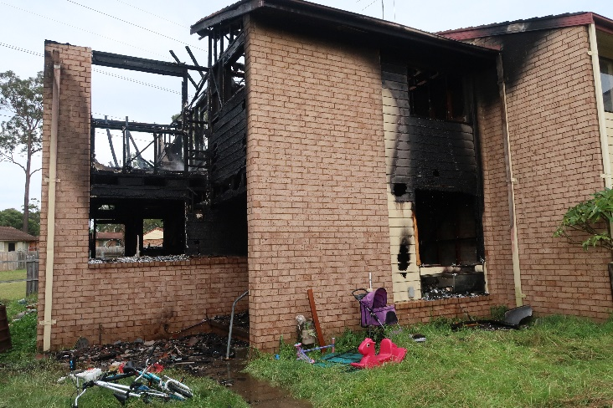
C
A
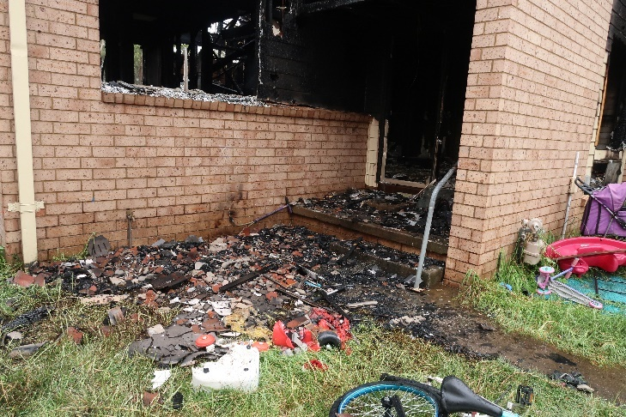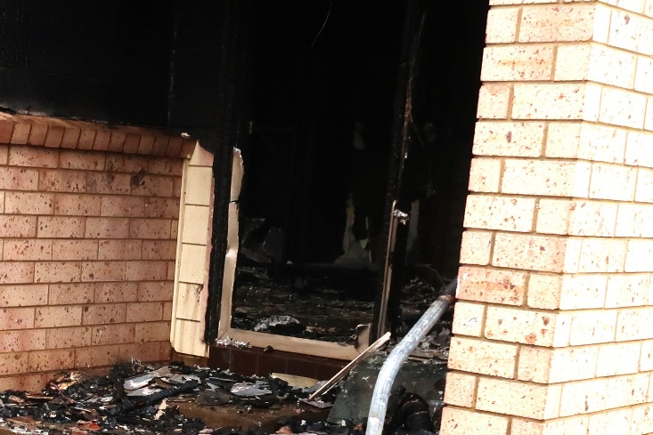
B
B

Alpha Side of the Main Fire Occupancy. A – Indications of a secondary breach into the Exposure Delta 1 roof space. The very low neutral plane (60 cm above the floor) is indicative of the extreme nature of the venting superheated gases produced by the hydrocarbon-laden polyurethane fuel load. Melting of the aluminium door frame B and window frame C is indicative of temperatures that exceeded 660°C at these points. The actions of firefighters stopped the fire spreading to Exposure Delta 1 D. Exposure Delta 2 E would have also been at risk if fire had taken hold within Exposure Delta 1. In situations where townhouses are involved in fire, investigations of the roof spaces of adjoining townhouses must be carried out without delay.
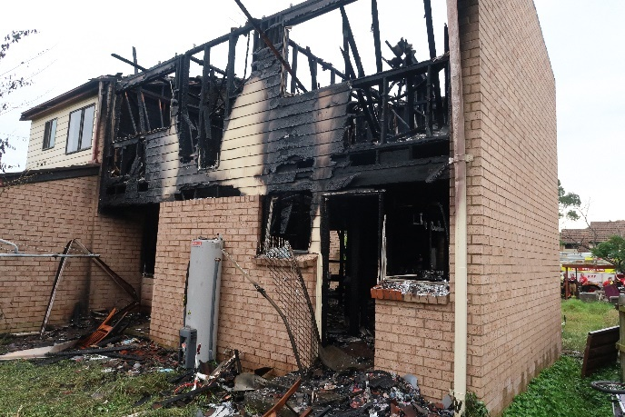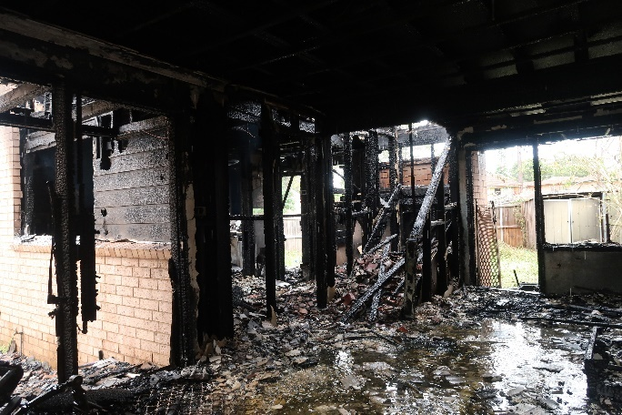
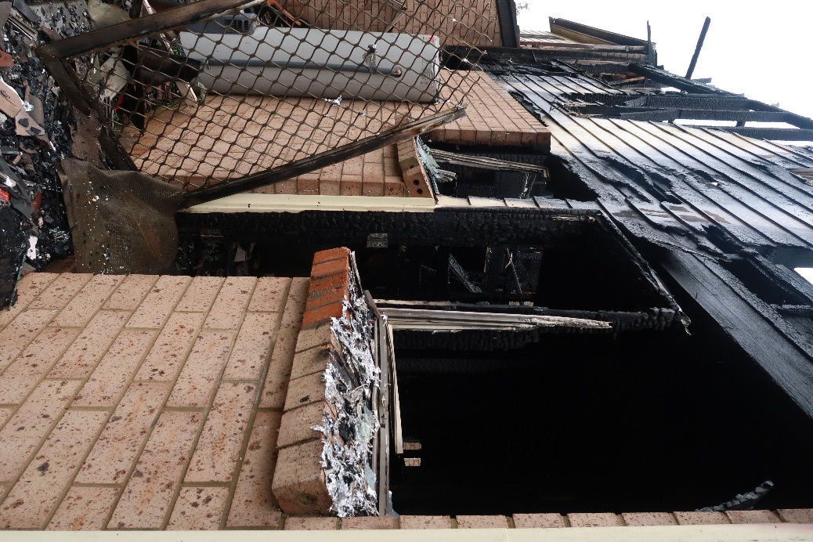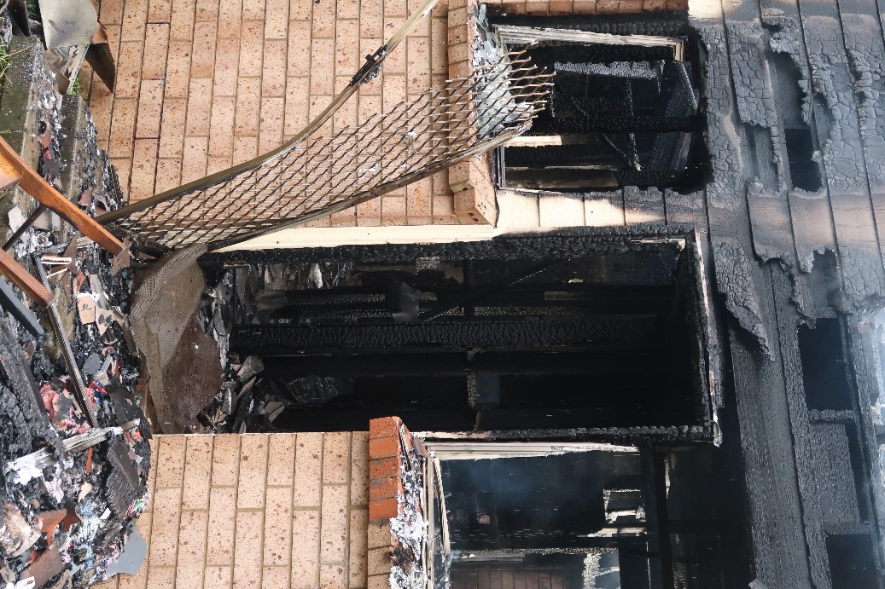
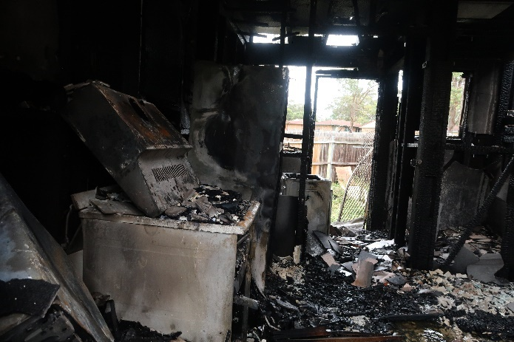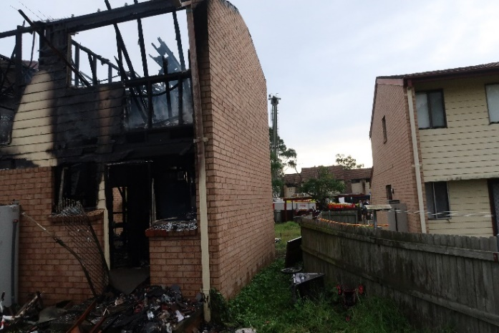

Charlie Side of the main fire occupancy. Fire damage to levels 1 and 2 of the townhouse is severe. Burning polyurethane foam within lounges, chairs and mattresses released large quantities of flammable hydrocarbon-laden gases, producing extreme fire behaviour including rapid fire spread and high heat release rates. Venting superheated gas flows of temperatures exceeding 660°C have resulted in melting of aluminium window and door frames to the level of the neutral plane.
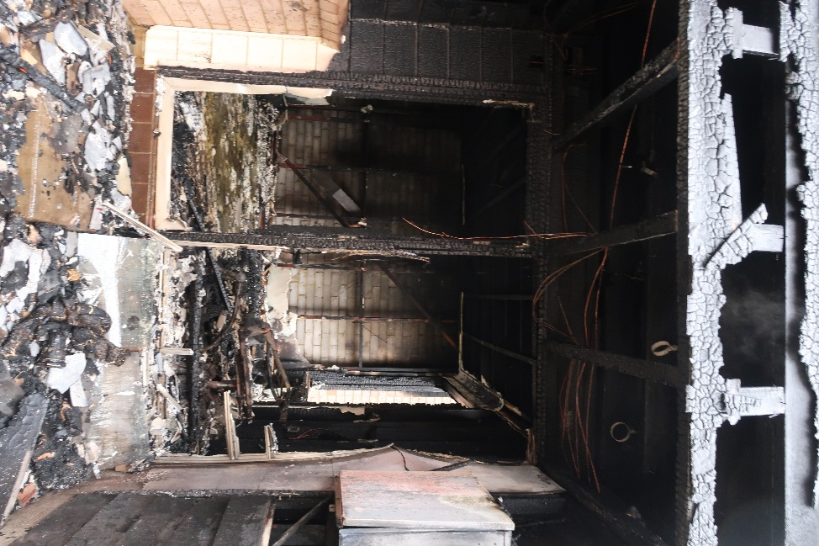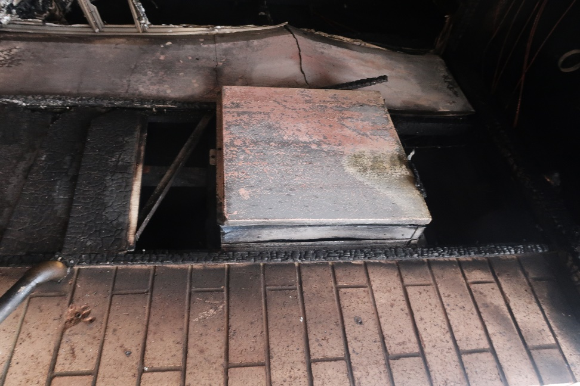
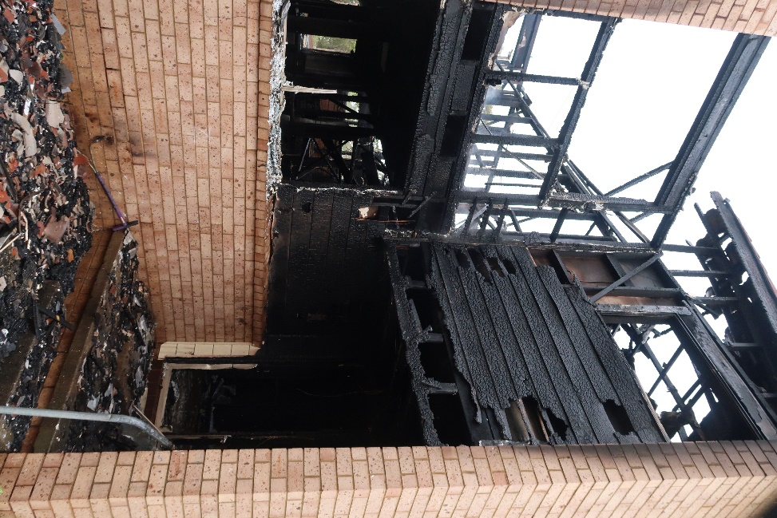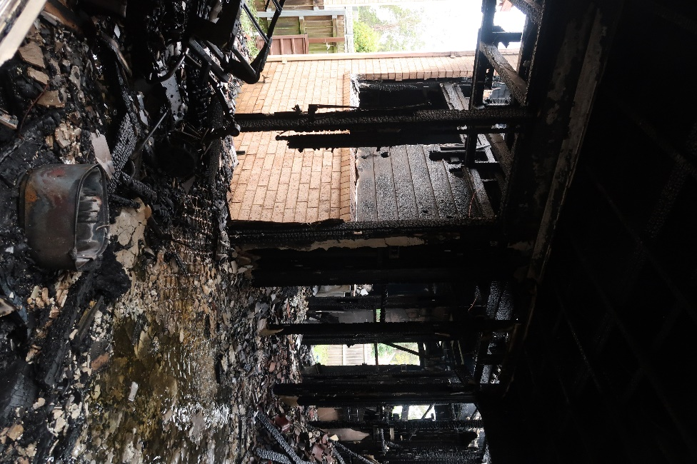

Severe fire damage to the townhouse interior, due to extreme fire conditions associated with burning polyurethane foam. Multiple flow-paths, consisting of venting superheated fire gases formed, travelled with high velocity and high pressure extended from areas of fire combustion to structure vent points. Upper photographs show the location of the electricity distribution board which was inaccessible to firefighters.

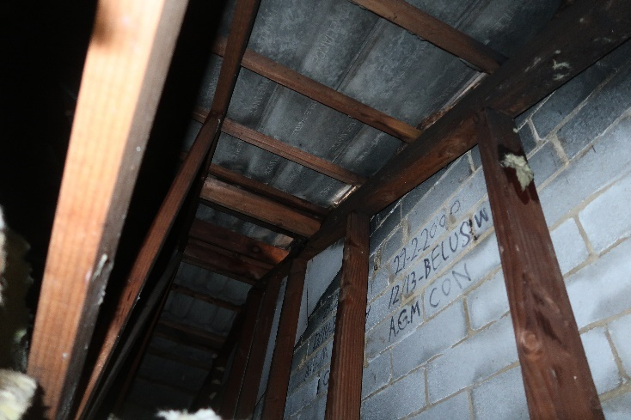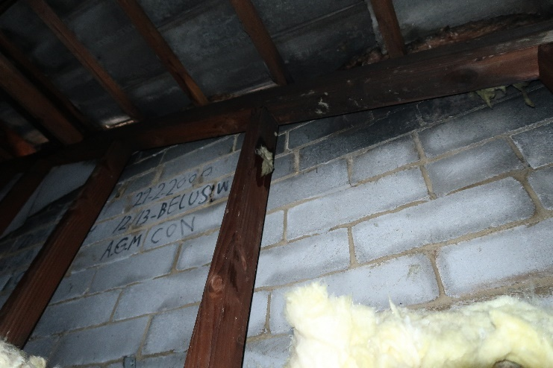
B
B
B
B
B
B
B
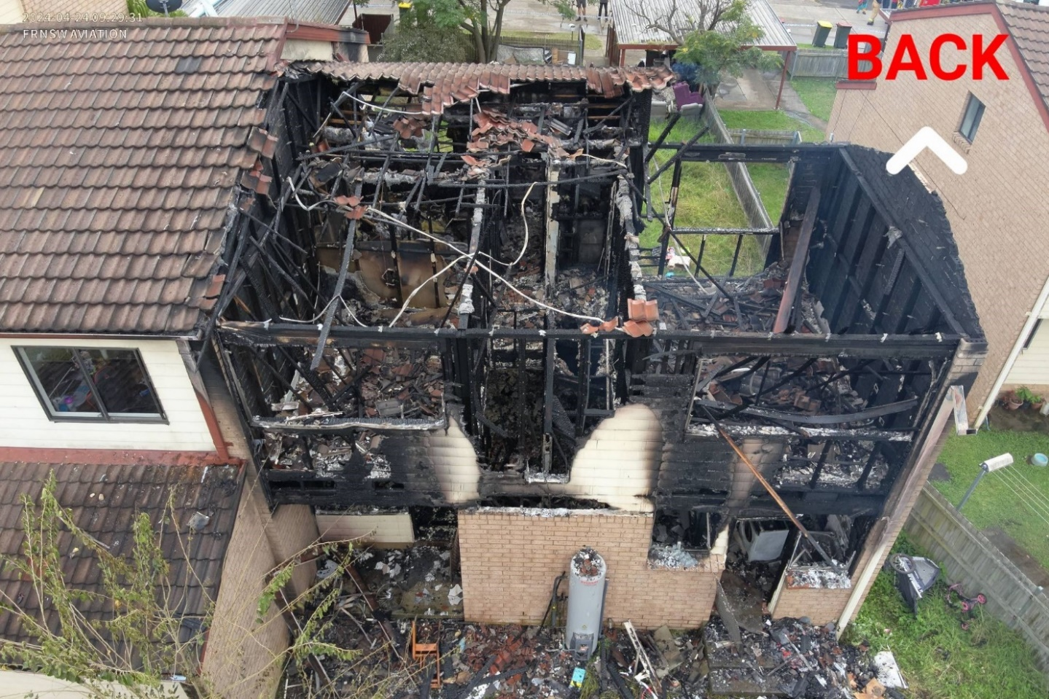
A
A
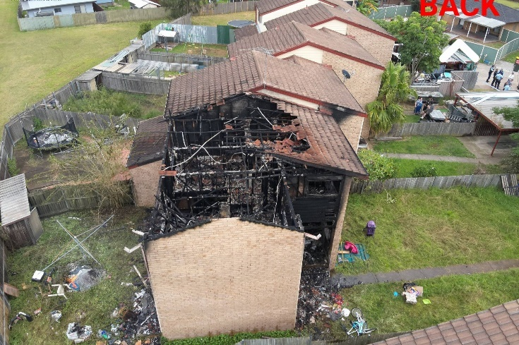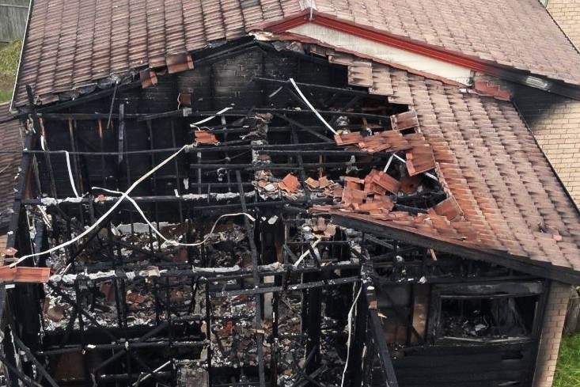
A

Townhouses at the Belus Way complex were separated by a brick wall that extended to the tile roof. Openings and gaps between the top of the wall and the roof tiles allowed fire to breach the wall in multiple places. Fire burning in the involved townhouse breached the separation wall at A and spread into the roof space of Exposure Delta 1 at B. The actions of firefighters prevented the fire from taking hold within the Exposure Delta 1 roof space, saving the exposure.
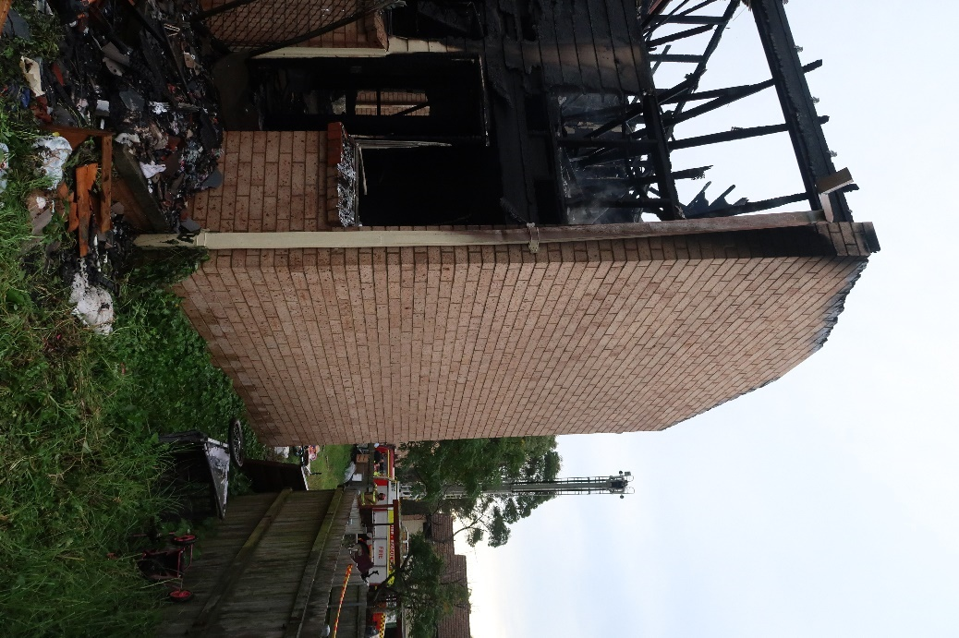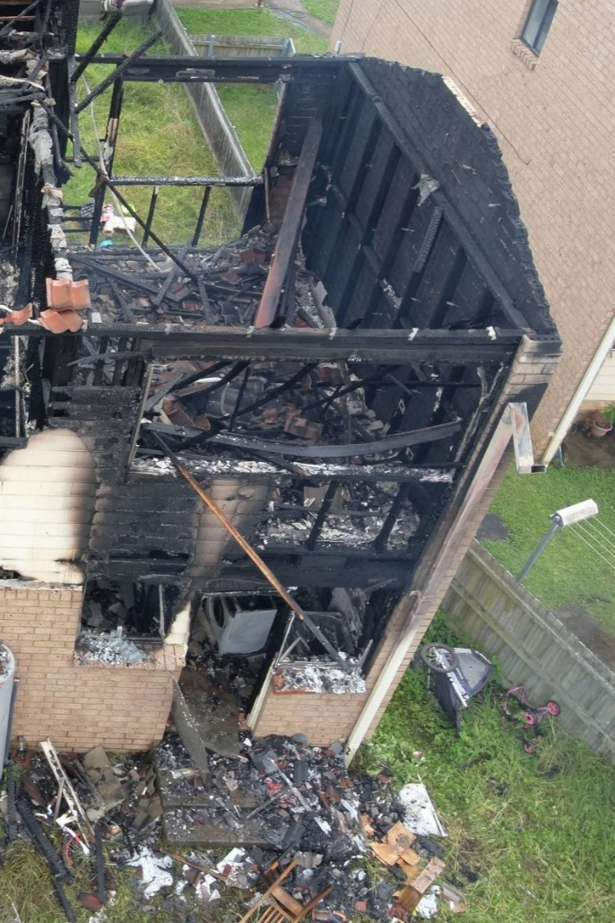
A
A
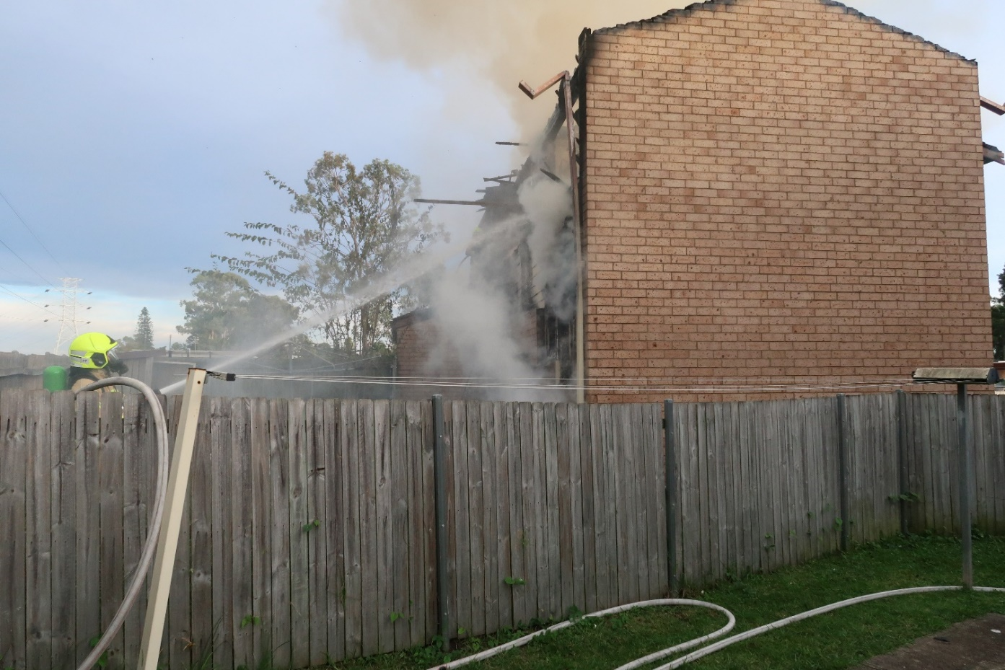
A

The Bravo side brick wall A was secured to the structural timber frame B of the townhouse. Severity of fire caused the timber frame B and fasteners to weaken, resulting in the wall becoming unstable. The upper wall C is freestanding and in danger of falling. Firefighters observed movement of the wall, indicating wall instability and possible collapse, necessitating establishment of a collapse zone.

