To be held at
‘CLUB YORK’ Function Centre
The Red Room
99 York Street
Sydney
(Near Market Street)

Time: 11.30 am for 12 noon

Date: Wednesday, 16th October 2024

Cost: $35 Per Person – Meal only
(Lucky number available at door)

To indicate attendance please forward the attached form to the Secretary:-
Ray Kelly

10 RIDGEWAY CRESCENT

QUAKERS HILL NSW 2763
Mobile: 0458 687 765
Email: nswfbretirees@gmail.com
Venue is within walking distance from Town Hall and George Street, near Queen Victoria building. Parking available below Queen Victoria building. Seating is limited to 90 so we urge members to book early to assist with catering and management of the event.
If attending, complete and return this form to indicate your attendance and type of payment.

Name

Address

Post Code

Service No.

Department

Payment can be made by Money Order payable to NSWFB Retirees Association.
Payment may also be made by written or electronic contact to the Firefighters Mutual Bank indicating NSW Fire Brigades Retirees Luncheon payment to Account No. 61102151S1

Cost $35.00 Per Person

Names of Attending
Please help us keep our records up to date by supplying any changes of information.

- Home contact No.

- Mobile Phone

- Email

- Area events and functions you are willing to attend

Do you still wish to receive information of future events by paper mail ?

Yes

No
THE NSW FIRE BRIGADES RETIREES
ASSOCIATION INCORPORATED

Proudly supported by The Firefighters Mutual Bank

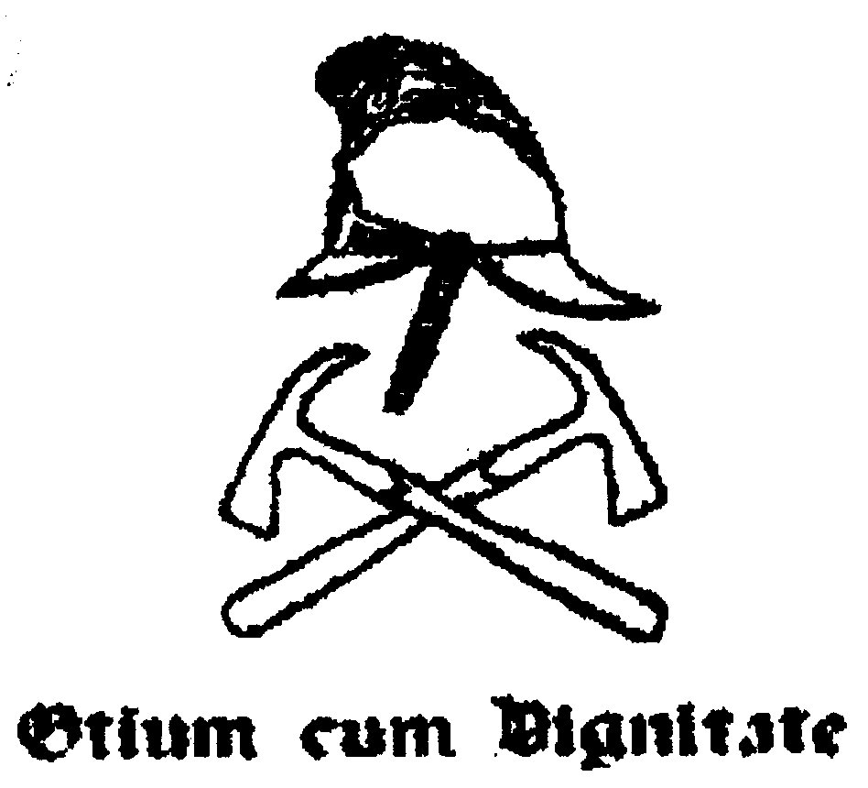

Don’t forget to visit our website for the latest up to date information/
www.nswfbr.org.au

The NSW Fire Brigades Retirees
Association Incorporated
Cordially invites you and your wife or partner
To attend our 45th Annual Reunion Luncheon

